Mental Health Tribunal

Hearing Experience Survey:

Report

Health and Community Consulting Group Pty Ltd

October 2022

|  |
| --- |
|  |
|  |
| |  |  |  | | --- | --- | --- | | **Dr Cheryl Reed** | **Email | CherylReed@hcconsultinggroup.com.au** | **Tel | 0432 663 990** | |

Table of Contents

Acknowledgements ii

Structure of this report ii

Reading this report ii

Definitions and abbreviation list ii

Executive summary iii

Purpose iii

Method iii

Findings iii

Conclusions and recommendations iv

Conclusions iv

Introduction 1

About this project 1

Purpose of this research 1

Structure of THE Survey 1

Research method 2

Survey Results 3

Who completed a survey? 3

Had they been to a hearing before? 5

What happened before the hearing? 7

What happened when people attended a hearing? 11

What happened after the hearing? 14

What were the outcomes for people? 17

Measuring the Mental Health Tribunal Strategic Plan 2021 - 2024 19

Conclusion and Recommendations 20

Conclusions 20

Recommendations 21

Appendix A: THE Survey (Attendees) 22

Appendix B: THE Survey (NON Attendees) 26

## Acknowledgements

Health and Community Consulting Group Pty Ltd would like to thank the mental health consumers, patients, carers, family and nominated persons who took the time to complete a survey at what is often a very difficult time. We would also like to acknowledge the work of the Tribunal Advisory Group (TAG) for their role in guiding and reviewing this work and the Consumer & Carer Engagement Officer and other staff for managing the distribution and return of surveys. **Templates and Add‑Ins**

## Structure of this report

The report is presented in four main sections:

* Introduction, which provides information on the purpose of the research
* Research method, which details how the research was conducted
* Survey results which present a description of the findings supported by charts and tables
* Conclusions and recommendations, which identifies opportunities to learn and improve through review of the research findings.

## Reading this report

The focus of this report is on measuring the performance of the Tribunal from the perspective of the patient, their carer, family or nominated person. The performance of mental health services was not measured.

When reporting, the results for carers, family and nominated persons have been combined due to their small sample size and overlap between categories. Due to the small sample sizes, results have not been tested for significance and comparisons between groups should be read as indicative only. Where percentages do not add to 100% this is due to a rounding effect and/or a multiple-choice question.

## Definitions and abbreviation list

|  |  |
| --- | --- |
| **Term** | **Description** |
| Act | The Mental Health Act 2014 |
| Carer | A non-paid person, usually a family member or friend, who supports a patient |
| Consumer | A person who is currently using an inpatient or community mental health service |
| HC Consulting Group | Health and Community Consulting Group Pty Ltd |
| IMHA | Independent Mental Health Advocacy |
| MHT | Mental Health Tribunal |
| Nominated person | A person the patient nominates to receive information and provide them with support in the event they require compulsory mental health treatment |
| TAG | Tribunal Advisory Group |
| THE Survey | Tribunal Hearing Experience Survey |
| Tribunal | Mental Health Tribunal |

# Executive summary

The Mental Health Tribunal (the Tribunal) commenced operation on 1 July 2014 under the [Mental Health Act](https://www.legislation.vic.gov.au/in-force/acts/mental-health-act-2014) (the Act). The Tribunal’s vision is to ensure that the principles and objectives of the Act are reflected in the experience of patients, carers, family and nominated persons. Since 2018, the Tribunal Hearing Experience (THE) Survey has provided an avenue for patients, carers, family and nominated persons to give feedback to the Tribunal on the implementation of this vision.

## Purpose

The purpose of this project was to provide an opportunity for people who were invited to a Tribunal hearing to give feedback on their experience. The results will be used to measure the performance of the Tribunal over time and to identify opportunities to improve the experience of patients, carers, family and nominated persons.

## Method

All patients, carers, family and nominated persons who were invited to a Tribunal hearing in May 2022 were posted an information sheet and THE Survey (Appendix A) 1-3 weeks after their hearing to provide feedback on their experience. Due to the low number of responses, the survey period was extended to hearings held in   
June 2022. For the first time, people invited to a hearing also received a text message with a link to THE Survey (where mobile phone numbers were available). A slightly abridged version of THE Survey was provided to people who did not attend a hearing (Appendix B).

In total, 2,034 people invited to attend a Tribunal hearing were asked to complete THE Survey (by mail and/or text). With 128 participants returning THE Survey, adjusting for undelivered mail, the effective response rate was approximately 7%, this is lower than the previous year (10%).

## Findings

Overall, the Tribunal performed well on all measures in THE Survey. While COVID 19 negatively impacted on some areas of experience for patients and their carers, families and nominated persons, it also brought about increased opportunities for remote participation in hearings. While overall experience with the Tribunal had declined slightly, as we move out of the pandemic, hopefulness for the future was at an all-time high.

### Before the hearing

* 63% received a copy of ‘How to prepare for your Tribunal hearing’
* 69% had enough time to prepare for the hearing
* 59% had enough information to prepare for the hearing
* 71% knew they could bring someone to support them to the hearing (such as a lawyer, nominated person, carer, other family member or friend).

### During the hearing

* 81% felt the Tribunal members explained what the hearing was about (including what they needed to decide)
* 68% considered that the Tribunal members listened to their opinions
* 75% considered that the Tribunal members treated them fairly throughout the hearing
* 73% felt the Tribunal members explained their decision in an understandable way

### After the hearing

* 73% received a copy of the Order or decision made by the Tribunal within two weeks
* 59% agreed with the outcome of the hearing
* 65% were informed that patients could appeal the outcome or request another hearing.

## Conclusions and recommendations

During THE Survey period in 2022, while the pandemic was nearing an end, the pandemic declaration was still in force in Victoria with some mandatory settings in place around reporting cases, isolation, mask wearing and entering health services. The Tribunal also had in place a [COVID Strategy](https://www.mht.vic.gov.au/sites/default/files/documents/202207/MHT%20COVID-19%20Strategy%20-%20July%202022%20update.pdf) to manage and mitigate the impacts of the pandemic. These changed conditions need to be considered when reviewing the results of THE Survey, particularly when comparing to previous results.

## Conclusions

Increasing the response rate to THE Survey

The response rate to THE Survey has continued to decline since its first administration. While this may have been influenced by COVID-19, and the availability of people (including health service staff) to support patients in completing a survey, the trend is nevertheless concerning. While extending the survey period increases the total number of responses received, it does not increase the representativeness of the sample or the response rate. The Tribunal should work with the Tribunal Advisory Group (TAG), health services and other stakeholders to identify more active ways to promote and support the completion of THE Surveys. Points for discussion may include the timing of the survey, distributing THE Survey with the Order rather than some weeks later, options for engaging the consumer and carer workforce where capacity is available, the use of reminder texts and improved promotion of THE Survey at health services (e.g. using local activities to promote the role of the Tribunal and THE Survey).

*Recommendation 1:* The Tribunal should consider ways to improve the response rate to THE Survey to increase the representativeness of the sample.

Choosing how to attend a Tribunal hearing

The pandemic has resulted in a change in the way hearings are held, with hearings pivoting to telephone and online methods. The opportunity for remote participation at hearings has extended attendance to people who were previously unable to attend. This has been particularly beneficial for patients not in hospital. While attendees have been very positive of their experience overall, particularly when participating online, how these opportunities are managed post-pandemic is important to maximise the engagement and participation of patients and their carers, families and nominated persons.

*Recommendation 2: In the post-pandemic period, patients should have a choice in how they attend a hearing, whether by telephone, online or in person.*

Improving the distribution of information

While the recent introduction of text messaging by the Tribunal has improved access to information, some patients still did not recall receiving the ‘*How to prepare for your hearing’* booklet. Having the booklet available online for download, with a link embedded in the text message, may help to improve access to this important resource.

*Recommendation 3: Text messages to people invited to a hearing, should include links to important resources, such as the ‘How to prepare for your hearing’ booklet, to provide an alternative contact point for people who (for whatever reason) do not receive mail correspondence from the Tribunal.*

Maintaining good communication at hearings

There was a very positive sentiment for the way the Tribunal members engaged with patients and their carers, families and nominated persons. *Kind*, *patient*, *caring* and *supportive* were adjectives commonly used to describe Tribunal members. While still positive, ratings of Tribunal members had declined since the previous survey. The area of relatively lower performance was ‘*listened to your opinions’* particularly for people who attended a hearing in person (rather than by phone or online). A number of factors may have influenced these findings, including COVID safe practices.

The Tribunal should work with members, the TAG and other stakeholders to consider how best to engage with patients and others at hearings when implementing the COVID Strategy. This might include review of Communication within the Competency Framework to ensure that the competency and performance indicators give sufficient direction to members, particularly in the establishment of good communication processes so that patients and others are encouraged to share their experience and ask questions of the health service and Tribunal members whether participating in person, by telephone or online.

*Recommendation 4: The Tribunal should review the Competency Framework for members to ensure that it provides sufficient guidance for communicating at hearings when people attend using different methods and in different circumstances (such as under the COVID Strategy).*

# Introduction

The vision of the Mental Health Tribunal (the Tribunal) is to ensure that the principles and objectives of Victoria’s mental health legislation are reflected in the experience of consumers and carers. A key strategic priority of the Tribunal is to maximise patient and carer participation at hearings. The Tribunal has over 140 members with hearings taking place at 57 venues in Victoria.

During THE Survey, the pandemic declaration was in force in Victoria, with mandatory requirements including wearing of masks in some settings, reporting of positive cases, isolation of positive cases and household contacts and limitations on visitations to some health settings. COVID 19 has also resulted in well-publicised reductions in workforce capacity, particularly for frontline health workforces. The Tribunal has in place a [COVID Strategy](https://www.mht.vic.gov.au/sites/default/files/documents/202207/MHT%20COVID-19%20Strategy%20-%20July%202022%20update.pdf) to manage and mitigate the impacts of the pandemic. These changed conditions may affect the results of THE Survey, particularly when compared to previous results.

## About this project

In Australia, consumer and carer experience of service surveys have been used nationally as both a process and outcome indicator of quality. As a process indicator, the offering of a survey demonstrates the importance of user experience within the system. As an outcome indicator, survey results measure the performance of the system.

Early in 2018, the Tribunal completed the development of the Tribunal Hearing Experience (THE) Survey. THE Survey is a self-completed user experience survey. In addition to providing data for quality improvement, it provides a measure of the effectiveness of the Tribunal and can assist in benchmarking the performance of the Tribunal against other services supporting people with mental illness and their carers.

After the successful implementation of THE Survey in 2019, the Tribunal worked with internal stakeholders, including the Consumer and Carer Tribunal Advisory Group (TAG) to develop a version of THE Survey suitable for use with people invited to a hearing but who did not attend.

## Purpose of this research

The purpose of this project was to provide an opportunity for people who were invited to attend a Tribunal hearing to give feedback on their experience. The results will be used to measure the performance of the Tribunal over time, identify opportunities to improve attendees’ experiences at hearings and/or to support invitees to attend hearings.

## Structure of THE Survey

THE Survey includes questions related to:

* ***Preparing for the hearing***: such as accessing information and help with hearing preparation
* ***Conduct related to the hearing***: such as reasons for non-attendance, getting support to attend the hearing, access to information about rights and responsibilities, the performance of the Tribunal members and the outcome and appeal processes
* ***After the hearing***: such as hopefulness for the future and overall experience.

THE Survey also included one open-ended question to capture further information from patients and others about their experiences at the Tribunal hearing (for attendees) and the reason for their absence (for non-attendees). THE Survey is included in Appendix A: Attendees and Appendix B: Non-attendees.

THE Survey is structured to separate experience before, during and after the hearing. This model of experience was developed and evaluated through research with patients and carers and reflects the expected activities of the Tribunal at each stage (Figure 1).

Figure 1: Model of hearing experience

Information and

preparation before

the hearing

Tribunal member

performance at

hearing

Overall experience

Hopefulness for the

future

Immediately after the

hearing

*Attendees only*

## Research method

All patients, carers, family members and nominated persons invited to a Tribunal hearing in May 2022 were asked to complete a survey through the mail and also by text where contact details were available. Due to a low response rate, the survey period was extended to June 2022. As with the previous survey, both attendees and non-attendees were invited to complete a survey. Non-attendees were given a slightly abridged version of THE Survey. The Tribunal conducted 9,543 hearings in 2020-2021. During this time, patients attended 62% of hearings with family members, carers and nominated persons attending less frequently (18%, 3%, and 3% respectively)[1] ([Annual Report 2020-2021](https://www.mht.vic.gov.au/sites/default/files/documents/202111/2020-2021%20MHT%20Annual%20Report.pdf))[2].

In total, 2,034 people invited to attend a Tribunal hearing were asked to complete THE Survey (by mail and/or text). With 128 participants returning THE Survey, adjusting for returned and undelivered mail, the effective response rate was approximately 7% (4% for non-attendees and 9% for attendees). This is slightly lower than the previous year (10%).

A small number of patients, carers and nominated persons were invited to attend more than one hearing and were eligible to receive multiple surveys.

|  |
| --- |
| The response rate to THE Survey has continued to decline since its first administration. While this may be influenced by COVID-19, and the availability of people (including health service staff) to support patients in completing a survey, the trend is nevertheless concerning. |

# Survey Results

This section provides an overview of the survey results.

## Who completed a survey?

Most of the respondents to THE Survey were patients (65%) either in hospital (28%) or not in hospital (37%) (Figure 2). However, while the number of surveys completed was much lower for carers (8%), family members (20%) and nominated persons (5%), their response rate was higher given the smaller population with these roles. These groups were also particularly likely to respond to the non-attendees’ survey (Table 1).

|  |  |
| --- | --- |
| Figure 2: Who completed a survey? | Table 1: Which survey did they complete? |
|  | |  |  |  | | --- | --- | --- | |  | **Attendees**  (n=89) | **Non-Attendees**  (n=34) | | Patient-in hospital | 34% | 15% | | Patient-not in hospital | 43% | 21% | | Family or friend | 15% | 35% | | Carer | 4% | 18% | | Nominated person | 3% | 9% | | Not sure | 1% | 3% | |

There was a substantial difference in the way respondents attended the hearing, with more people attending by video (49%) than in person (33%) or by telephone (18%) for the first time (Figure 3). This change in hearing management reflects the implementation of the Tribunal’s COVID Strategy.

Figure 3: Trend in the method of attending a hearing

*Video and telephone attendance have been combined as they were not asked separately in previous years.

Most respondents to THE survey were very supportive of the flexible ways they could attend a hearing. This flexibility may also be responsible for the increased attendance at hearings of patients not in hospital (37% compared to 29% in the previous survey). Moving into the post-pandemic period, choice in the method of attending a hearing will be important for patients. While there can be issues in attending online (such as getting a link in time and managing the technology), attendees were most positive overall when using this technology and less positive when joining a hearing by telephone.

“I found the process of the hearing easy to follow on the last phone hook-up conference call, could have been … better if on a zoom or such.”

*Family member, attended by telephone*

“Understand covid concerns but hearings in person are much fairer for people involved. Some could be held in person safely.”

*Family member, attended by video*

Maintaining the same relationship with people attending a hearing over the telephone or online requires a different set of skills than conducting face-to-face hearings. This is particularly the case in the short term as COVID has expedited a change in hearing format.

“Only the legal member returned to the screen to deliver the verdict. I think it is very poor…MHT hearings must return to face to face. The outrageously unfair audio hearings have been replaced with video hearings leading to a most dehumanising experience.”

*Nominated person, attended by video*

|  |
| --- |
| The pandemic has resulted in a change in the way hearings are held, with hearings pivoting to telephone and online (video) methods. The opportunity for remote participation at hearings has extended attendance to people who were previously excluded for a variety of reasons including distance, caring duties, work and other appointments. While attendees have been very positive of their experience overall, particularly when participating online, how these opportunities are managed post-pandemic is important to maximise the engagement and participation of patients and their carers, families and nominated persons. |

## Had they been to a hearing before?

Most respondents who attended a hearing (64%) had been to a hearing before, however, a large number (33%) were attending for the first time (2% were unsure if they had previously been to a hearing) (Figure 4).

Patients and their carers, family and nominated persons had similar rates of first-time attendance overall (34% and 30% respectively) (Table 2). However, inpatients were twice as likely as patients not in hospital to have attended for the first time (44% compared to 22%).

|  |  |
| --- | --- |
| Figure 4: First time attending a hearing (time comparison) | Table 2: First time invited/ attending by role at hearing |
|  | |  |  |  |  |  | | --- | --- | --- | --- | --- | |  | | Subtotal Patient | | Subtotal family, carers and nominated persons | | First time invited (non-attendees, n=32) | | | | | | Yes | 18% | | 20% | | | No | 73% | | 80% | | | Note sure | 9% | | - | | | First time attending a hearing (attendees, n=89) | | | | | | Yes | 34% | | 30% | | | No | 65% | | 70% | | | Not sure | 1% | | - | | |

For respondents who did not attend the hearing, 22% had been invited for the first time (Figure 4). These results were consistent with the previous survey (Figure 5).

Figure 5: Trend in first time invitations and attendances

In open-ended feedback, respondents commented that attending a hearing for the first time can be daunting, but members were inclusive and welcoming.

“I was very pleased that the Tribunal members were impartial, kind, friendly and genuinely listened to my story. I hope more patients will seek treatment orders when applicable and move past their mental health barriers to fight for their rights.”

*Patient in hospital, attending a hearing for the first time, by video*

“I have attended more than one Mental Health Tribunal … and have found them to be well-conducted with a professional approach, very good communication, respect and inclusion. My opinions were heard and matters were explained well. There was a thoroughness and an understanding of the details and what was being asked that was reassuring.”

*Patient in hospital, attended previous hearings, by video*

Consistent with the previous survey, the majority of respondents had attended their most recent hearing within the last four weeks (57%). The recency of the hearing suggests that recall of the event should be high, increasing the face validity of the survey results.

## What happened before the hearing?

Preparing for a hearing includes a range of activities such as receiving information, collating materials, communicating with relevant parties and knowing your rights and responsibilities. Most respondents (58%) had some help preparing for a hearing. There were similar rates of access and sources of support by role (Table 3).

There were more respondents reporting they had no help to prepare for the hearing compared to the previous survey (40% compared to 32%). This was reflected in a slight decrease in support from lawyers, nominated persons, carers and families.

Consistent with the previous survey, staff from the mental health services remained the most likely group to provide help with hearing preparation across patients, carers, family and nominated persons. This shows the importance of maintaining training and resources for this group.

Table 3: Source of help with hearing preparation by role at the hearing

|  |  |  |  |  |
| --- | --- | --- | --- | --- |
|  | Total (n=128) | Patient-in hospital (n=35) | Patient-not in hospital (n=45) | Carer, family and nominated person (n=41) |
| No one | 40% | 39% | 46% | 32% |
| Staff from the health service | 32% | 29% | 30% | 47% |
| Lawyer | 13% | 18% | 14% | 5% |
| Independent Mental Health Advocacy | 9% | 7% | 8% | 5% |
| Family | 5% | 11% | 3% | 0% |
| Carer | 3% | 4% | 3% | 5% |
| Nominated person | 2% | 4% | 3% | 0% |
| Other | 5% | 7% | 3% | 5% |
| Not sure | 2% | 4% | 3% | 0% |

The Tribunal is responsible for ensuring that patients (and in some cases carers, family and nominated persons), receive information about the hearing, their rights and support services. Approximately three quarters of respondents (77%) received a written notice about the hearing (Figure 6). The Tribunal has recently commenced providing additional information by text message (where phone numbers are available). More than half of the respondents had received a text message from the Tribunal (56%). Of the respondents who had not received written notice of a hearing, 43% did receive a text message. This demonstrates the value of text messages as an alternative source of information for people invited to a hearing. The proportion of people receiving a text message is likely to increase as health services become more aware of the need to maintain the accuracy of this information.

Patients who attended a hearing were asked four additional questions about the information they received (Figure 6). Most respondents (63%) recalled receiving a copy of *How to prepare for Your Tribunal hearing* and 59% felt they had enough information to prepare for the hearing. Of the respondents who felt they needed more information to prepare, 55% had received a copy of *How to prepare for Your Tribunal hearing,* suggesting that there is room to improve access to this material.

Figure 6: Before the hearing

Furthermore, people who did not attend the hearing, while reporting that they received the notice and text message (75% and 69% respectively), they were less likely than attendees to recall receiving a copy of *How to prepare for your Tribunal hearing* (42% compared to 67%) and more likely to identify a lack of time and information to prepare for the hearing (Figure 7).

Figure 7: Before for the hearing by attendance (% agree)

In open-ended feedback, a few family members commented that they had received the invitation in error and felt that it was meant for the patient. In one case, the family member felt that only ‘paid carers’ [sic] were able to attend (e.g. people in receipt of a carer allowance or payment). Several family members also commented on the survey being the first communication they had received from the Tribunal (i.e. they had not received a notice of hearing).

“I have received this letter I feel in the assumption that it was meant for my son... I have been a paid carer in the past…”

*Family member, did not attend*

“This is the first letter I have ever received about a hearing. No idea who is [name withheld] case manager, if he has one.”

*Family member, did not attend*

Most areas of experience measured had improved or remained relatively steady since the last survey. The exception was ‘knowing you could bring a friend’ which has shown a steady decline since surveying began (Figure 8).

Figure 8: Before for the hearing time comparison - % agreement

There were some marginal differences between inpatients, patients not in hospital and carers/family/nominated persons (Table 4). Patients not in hospital were less likely to agree that they had enough information to prepare than patients in hospital (54% compared to 68%). As the rates of receiving a copy of ‘*How to prepare for Your Tribunal hearing’* were consistent between the two groups, the additional information required may not be the responsibility of the Tribunal to provide (e.g. it may relate to information from the health service such as doctor’s reports).

Table 4: Experience before the hearing by role at the hearing (% agreement)

|  |  |  |  |
| --- | --- | --- | --- |
| Did you…? | Patient in hospital (n≈34) | Patient not in hospital (n≈45) | Carer, family,  nominated person (n≈40) |
| Receive written notice | 72% | 84% | 78% |
| Receive a text message | 50% | 49% | 73% |
| Receive a copy of 'How to prepare…' | 58% | 68% | NA |
| Have enough time to prepare | 70% | 69% | NA |
| Have enough information to prepare | 68% | 54% | NA |
| Know you could bring a  support person | 73% | 72% | NA |

In open ended feedback, respondents who did not attend a hearing mentioned a range of reasons including competing appointments, travel issues, asked not to by the patient, not receiving the notification or supporting documents, concerns about protecting the patient’s feelings or relationship. Some people also did not attend because they felt the result was inevitable or trusted the representation provided by those who did attend.

“Because my voice would not matter.”

*Patient in hospital, did not attend*

“I was quite certain, due to only recently being discharged from hospital, that I would remain on the treatment order. I also trusted my case manager to advocate on my behalf after we had a lengthy discussion about the Tribunal, and he did.”

*Patient not in hospital, did not attend*

“Difficult to say difficult things about family members and not diminish them.”

*Carer, did not attend*

“Too far to travel.”

*Family member, did not attend*

“Did not know anything about [the hearing].”

*Family member, did not attend*

|  |
| --- |
| While the recent introduction of text messaging has improved access to information, it is important that the Tribunal continues to work with health services to ensure that the Tribunal database is up-to-date. Some patients did not recall receiving the ‘*How to prepare for your hearing’* booklet and felt they needed more information to prepare for the hearing. Having the booklet available for download, with a link embedded in the text message, may help to improve access to this important resource. |

## What happened when people attended a hearing?

How the Tribunal members conduct the hearing has a big impact on how patients, carers and others experience the process. Despite the difficult circumstances, people who attended a hearing were very positive of the conduct of Tribunal members. Overall survey results of hearing attendees (Figure 9) indicated:

* 81% felt the Tribunal members explained what the hearing was about (including what they needed to decide)
* 68% considered that the Tribunal members listened to their opinions
* 75% considered that the Tribunal members treated them fairly throughout the hearing
* 73% felt the Tribunal members explained their decision in an understandable way.

Figure 9: Experience at the hearing

While the results had declined in all areas since the previous survey (Figure 10), people attending a hearing were still very positive of their experience.

Figure 10: Experience at the hearing time comparison - % agreement

“Members were very professional and fair.”

*In patient, attended in person*

“I found the members to be open and honest, they cared about what i said, listened to me. I felt they were really fair when discussing the problems I faced. I was really happy with the process, even if i disagreed with the outcome. I am happy with the members I was lucky enough to have presiding over my hearing.”

*Patient not in hospital, attended by video*

To better understand the decline in experience at the Tribunal, responses to each of the four questions were combined into an index out of 100. The overall experience at the Tribunal was 75 out of 100. When this index was analysed against the responses to other questions in the survey, it was found that people attending a hearing in person had a significantly lower index than people who attended either by phone or online (68 compared to 84 and 85 respectively). This may relate to COVID-19 practices in place at face-to-face hearings (e.g. wearing masks and socially isolating).

A minority of patients were unhappy with the experience of appearing before the Tribunal. Some patients felt they were not treated fairly or that the Tribunal was not fair or transparent in their decision making.

“Very unfair. Very grateful to the lawyers and community workers only”

*Patient not in hospital, attended by video*

“I don't feel they obeyed the law and acted in my best interest...”

*Patient not in hospital, attended in person*

We feel that the panel was biased in spite of the facts that were presented …They refused to release the patient from the hospital … [despite the] parent certifying that they have support in place to support the patient... The irony was that the patient was discharge in the same week of the hearing…

*Family member, attended by video*

Overall, patients had a less positive hearing experience compared to carers, family and nominated persons. There was some variation in experience of the hearing between inpatients and patients not in hospital, with inpatients more likely to agree that the reason for the hearing was well explained (84% and 77% respectively), they were treated fairly (79% compared to 67%) and the decision was explained (79% compared to 65%) (Table 5).

|  |
| --- |
| Continuing the findings of previous surveys, people attending hearings valued the fairness, respect and recovery focus of Tribunal members. Patients in hospital were slightly more positive than patients not in hospital. Where patients did not have a positive experience of the hearing, their comments in open ended feedback related to a lack of transparency in decision making, lack of access to current medical reports, and concerns about diagnosis and mental health treatment. |

Table 5: Experience attending by role at the hearing (% agreement)

|  |  |  |  |
| --- | --- | --- | --- |
| **Did the Tribunal members…?** | **Patient in hospital** (n≈35) | **Patient not in hospital** (n≈45) | **Carer, family,  nominated persons** (n≈42) |
| Explain what the hearing was about | 84% | 77% | 94% |
| Listen to your opinions | 67% | 68% | 76% |
| Treat you fairly | 79% | 67% | 94% |
| Explain their decision to you | 79% | 65% | 88% |

In open ended feedback, family, carers and nominated persons focussed positively on the members taking time to understand the issues, listen to patients and their carers, families and nominated persons, and explain what was happening to the patient.

“All members of the Tribunal respectfully listen carefully to the client and family members, clearly explain the process, ask questions that assist the client to understand what criteria they base their decision on.”

*Family member, attended by video*

“The Tribunal 'judges' have a difficult job to do but when I have attended to support my mother (involuntary treatment order) I found that they were down to earth, supportive and empathetic in general.”

*Family member, attended in person*

“The Tribunal members attempted a variety of strategies to engage with the client all of which were kind, patient, respectful, and inclusive. The tribunal members always checked in with the client, making sure he understood what was being said. Thank-you Tribunal members and all the other staff involved in providing an outstanding service to Victoria!”

*Family member, attended in person*

|  |
| --- |
| There was a very positive sentiment for the way the Tribunal members engaged with patients and their carers, families and nominated persons. *Kind*, *patient*, *caring* and *supportive* were adjectives commonly used to describe Tribunal members. While still positive, ratings of Tribunal members had declined since the previous survey. The area of relatively lower performance was ‘listened to your opinions’ particularly for people who attended a hearing in person (rather than by phone or online). A number of factors may have influenced these findings, including COVID safe practices. |

## What happened after the hearing?

The Tribunal performed well in relation to what happened after the hearing (Figure 11). The majority of respondents agreed that they:

* Received a copy of the Order or decision made by the Tribunal within two weeks (73%)
* Agreed with the outcome of the hearing (59%)
* Were informed that patients can appeal the outcome or request another hearing (65%).

Figure 11: Experience after the hearing

Across all areas measured, respondents who did not attend a hearing reported less positive outcomes than respondents who attended a hearing (Figure 12).

Figure 12: Experience after the hearing by attendance (% agree)

Respondents to the current survey were more likely to have received a copy of the Order and know they could appeal the outcome of the hearing than respondents to previous surveys (Figure 13). They were slightly less likely to agree with the outcome of the hearing.

Figure 13: Experience after the hearing time comparison - % agreement

Family, carers and nominated persons reported the most positive experience after the hearing (Table 6). In particular, they were more likely than patients to agree with the decision made by the Tribunal (81%, compared to 60% of inpatients and 39% of patients not in hospital) and have received a copy of the order (76% compared to 72% of inpatients and 71% of patients not in hospital). Patients not in hospital were less likely to agree with the outcome than patients in hospital (39% compared to 60% of inpatients).

Table 6: Experience after the hearing by role at the hearing (% agreement)

|  |  |  |  |
| --- | --- | --- | --- |
| **Did you…?** | Patient in hospital (n≈35) | Patient not in hospital (n≈45) | Carer, family,  nominated persons (n≈42) |
| Receive a copy of the Order | 72% | 71% | 76% |
| Agree with the outcome | 60% | 39% | 81% |
| Informed patients can appeal | 63% | 60% | 72% |

Open-ended feedback indicated that when patients disagreed with the outcome of a hearing, the issues generally related to feeling the results were not transparent and the patient or family experience not adequately considered in making the decision or setting the hearing date.

“I am not happy with the service; you are supposed to understand my situation but you don't. I had court on the [date of the hearing]. I told you the date.”

*Patient not in hospital, did not attend*

“It was terrible. Shocking. Did not listen to anything I said. I have serious health problems and they didn't listen.”

*Patient not in hospital, did not attend*

“Very poor. I had a hearing without any report as my report came after the Tribunal's hearing…”

*Patient not in hospital, did not attend*

There were also a few comments related to communication. While it is difficult for patients and their carers, families and nominated persons to know the different areas of responsibility between the Tribunal and the health services, several comments related to a lack of responsiveness from the Tribunal.

“I have previously communicated to the MHT requesting notes for a previous Tribunal hearing that related to a family member and despite emailing and calling to follow up, I never received a response which was disappointing. Communication lines from the MHT to family members supporting patients could benefit from review and improvements made to processes so that queries are followed up in a timely manner.”

*Family member*

“First Tribunal was postponed, but I had to get on to the treating team to find this out. Then the outcome of second Tribunal was never explained to us. After 1 week I had to try and get some information about the outcome. No one rang or contacted us.”

*Family member*

## What were the outcomes for people?

The Tribunal performed moderately on the outcome measures. While overall experience was relatively low (38% excellent/very good) respondents were more hopeful for the future (47% excellent/very good) (Figure 14). People who attended a hearing were much more positive than those who did not (Figure 15).

Family, carers and nominated persons had a more positive overall experience than did patients (48% compared to inpatients and patients not in hospital – both 33%). They were however, substantially less hopeful for the future (30% compared to 55% inpatients and 50% patients not in hospital) (Table 7).

Looking at the results over time, while hopefulness for the future has increased since the previous survey, the overall experience at the Tribunal has decreased (48% to 38%) (Figure 16). Interestingly, this decrease is only slightly influenced by the change in the method of attending a hearing with the very positive experience of people attending the hearing online (55% excellent/very good), offsetting the poorer experience of people attending by telephone (audio only) (33% excellent/very good).

|  |  |
| --- | --- |
| Figure 14: Overall outcomes | Figure 15: Outcomes by attendance at the hearing (% Excellent/Very good) |
|  |  |

|  |  |
| --- | --- |
| Figure 16: Trend in outcomes (% Excellent/very good) | Table 7: Outcomes by role at the hearing (% Excellent/very good) |

|  |  |  |  |
| --- | --- | --- | --- |
| How would you rate your…? | Patient in hospital (n≈35) | Patient not in hospital (n≈45) | Carer, family,  nominated persons (n≈42) |
| Hopefulness for the future | 50% | 55% | 30% |
| Overall experience | 33% | 33% | 48% |

In some cases, the experience of attending the Tribunal had a very positive impact on a patient

“… at first I expected that I would not get a fair go but much to my surprise I was treated with respect and felt that my side of the story was taken into serious consideration. ‘*I was given a fair chance*’. Fortunately, I was found in favour. It instilled a sense of control which I am sad to say can be lacking in my position. But now I feel not so fearful of the Tribunal process. I feel my opinion does matter, that I have been heard. For that I am grateful. I now work with the mental health team of my own accord, a free man. Therefore, I have no reason to run for the hills. I am now 'respected'. Priceless.”

*Patient not in hospital*

“…I have been given insight to my predicament by the Tribunal…”

*Patient not in hospital*

## Measuring the Mental Health Tribunal Strategic Plan 2021 - 2024

The operations of the Tribunal are guided by a [Strategic Plan 2021-2024](https://www.mht.vic.gov.au/sites/default/files/documents/202208/MHT%20Strategic%20Plan%202021-2024%20%28August%202022%29.pdf) which sets out the Tribunal’s vision, mission, values and strategic priorities. The Plan identifies the core values under which the Tribunal operates, including *collaborative*, *fair*, and *respectful*. The Plan also highlights the importance of lived experience, human rights, recovery, least restrictive treatment and the participation of consumers, carers and clinicians. These core values can be measured through THE Survey (Table 8).

Table 8: Measuring the outcomes

|  |  |
| --- | --- |
| **Core value** | **Measurement calculation** |
| Collaborative | Collaboration can be measured, in part, by the proportion of patients who attended a hearing in the survey period[3]. Because not all patients have a carer or nominated person, these attendees have not been included in the calculation. As collaboration is broader than patient attendance at hearings, this index has been labeled as *patient attendance at hearings.* |
| Fair | The survey includes a question on *fair treatment* (Q11). The proportion of respondents that agree they were treated fairly throughout the hearing was used as an index of fairness. |
| Respect | Respectfulness has been measured by calculating the proportion of respondents that agreed the Tribunal members *explained what the hearing was about*, *listened* to the opinion of the respondent and *explained their decision clearly*. |

As discussed previously, Tribunal members received lower ratings in some areas for people attending a hearing in person. Consequently, a slight decline was found in the implementation of the Tribunal’s core values (Figure 17). Conversely, the increased use of technology to hold hearings remoted, driven by the pandemic, has resulted in an increase in patient participation at hearings.

Figure 17: Indices of the Tribunal's core values

# Conclusion and Recommendations

During THE Survey period in 2022, the pandemic declaration was in force in Victoria, with mandatory requirements including wearing of masks in some settings, reporting of positive cases, isolation of positive cases and household contacts, and limitations on visitations to some health settings. COVID 19 has also resulted in well-publicised reductions in workforce capacity, particularly for frontline health workforces. The Tribunal has in place a [COVID Strategy](https://www.mht.vic.gov.au/sites/default/files/documents/202207/MHT%20COVID-19%20Strategy%20-%20July%202022%20update.pdf) to manage and mitigate the impacts of the pandemic. These changed conditions may have affected the results of THE Survey, particularly when compared to previous results.

## Conclusions

Increasing the response rate to THE Survey

The response rate to THE Survey has continued to decline since its first administration. While this may be influenced by COVID-19, and the availability of people (including health service staff) to support patients in completing a survey, the trend is nevertheless concerning. While extending the survey period increases the total number of responses received, it does not increase the representativeness of the sample or the response rate. The Tribunal should work with the TAG, health services and other stakeholders to identify more active ways to promote and support the completion of THE Surveys. Points for discussion may include the timing of the survey, distributing THE Survey with the Order rather than some weeks later, options for engaging the consumer and carer workforce where capacity is available, the use of reminder texts and improved promotion of THE Survey at health services (e.g. using local activities to promote the role of the Tribunal and THE Survey).

Choosing how to attend a Tribunal hearing

The pandemic has resulted in a change in the way hearings are held, with hearings pivoting to telephone and online methods. The opportunity for remote participation at hearings has extended attendance to people who were previously unable to attend for a variety of reasons including distance, caring duties, work and other appointments. This has been particularly beneficial for patients not in hospital. While attendees have been very positive of their experience overall, particularly when participating online, how these opportunities are managed post-pandemic is important to maximise the engagement and participation of patients and their carers, families and nominated persons.

Improving the distribution of information

While the recent introduction of text messaging by the Tribunal has improved access to information, it is important that the Tribunal continues to work with health services to ensure that the Tribunal database is up-to-date. A few patients did not recall receiving the ‘*How to prepare for your hearing’* booklet. Having the booklet available for download, with a link embedded in the text message, may help to improve access to this important resource.

Maintaining good communication at hearings

There was a very positive sentiment for the way the Tribunal members engaged with patients and their carers, families and nominated persons. *Kind*, *patient*, *caring* and *supportive* were adjectives commonly used to describe Tribunal members. While still positive, ratings of Tribunal members had declined since the previous survey. The area of relatively lower performance was ‘*listened to your opinions’* particularly for people who attended a hearing in person (rather than by phone or online). A number of factors may have influenced these findings, including COVID safe practices.

The Tribunal should work with members, the TAG and other stakeholders to consider how best to engage with patients and others at hearings when implementing the COVID Strategy. This might include review of Communication within the Competency Framework to ensure that the competency and performance indicators give sufficient direction to members, particularly in the establishment of good communication processes so that patients and others are encouraged to share their experience and ask questions of the health service and Tribunal members whether participating in person, by telephone or online.

## Recommendations

*Recommendation 1:* The Tribunal should consider ways to improve the response rate to THE Survey to increase the representativeness of the sample.

*Recommendation 2:* In the post-pandemic period, patients should have a choice in how they attend a hearing, whether by telephone, online or in person.

*Recommendation 3:* Text messages to people invited to a hearing, should include links to important resources, such as the ‘*How to prepare for your hearing’* booklet, to provide an alternative contact point for people who do not receive mail correspondence from the Tribunal.

*Recommendation 4:* The Tribunal should review the Competency Framework for members to ensure that it provides sufficient guidance for communicating at hearings when people attend using different methods and in different circumstances (such as under the COVID Strategy).

# Appendix A:

# THE Survey (Attendees)

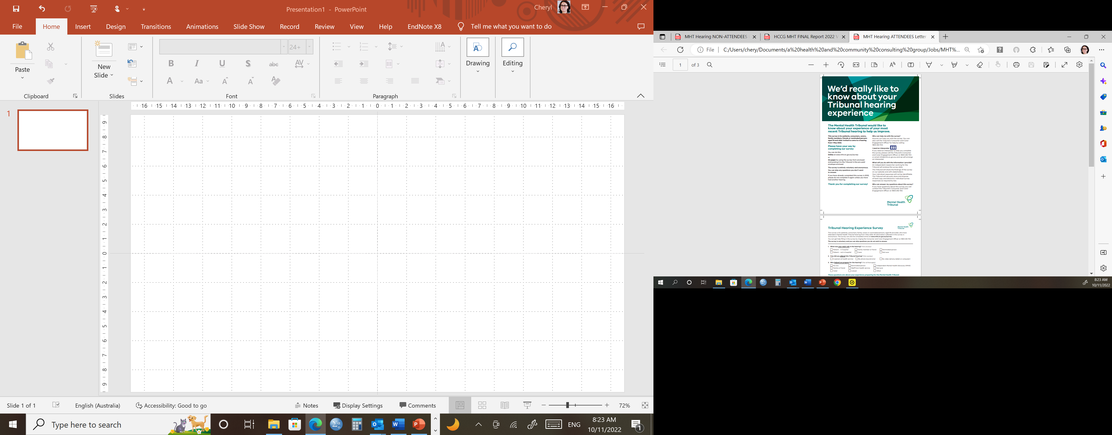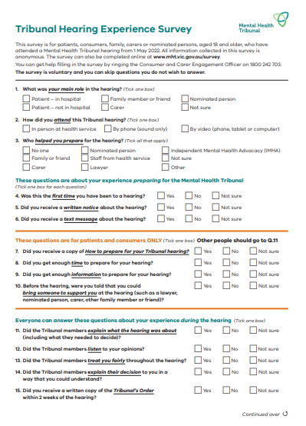

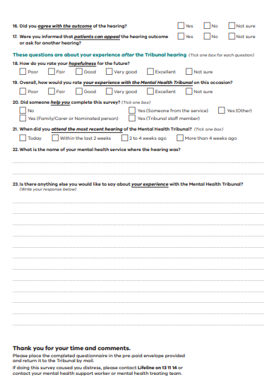

# Appendix B:

# THE Survey (NON Attendees)

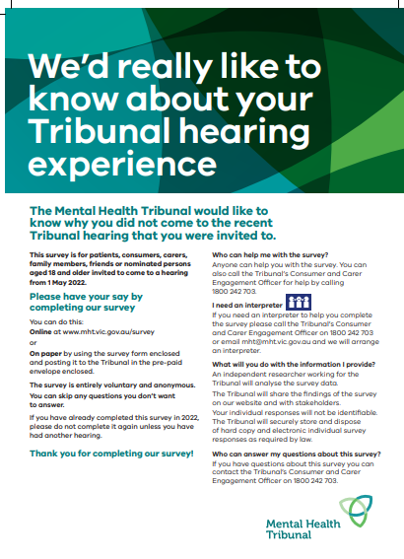

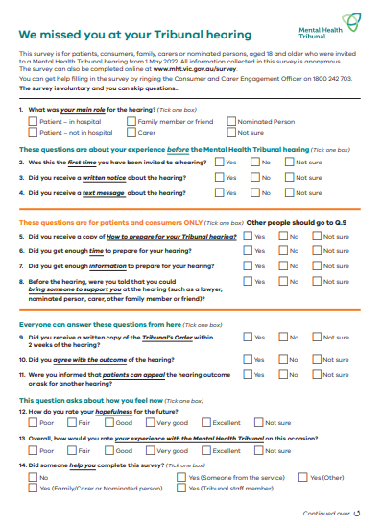

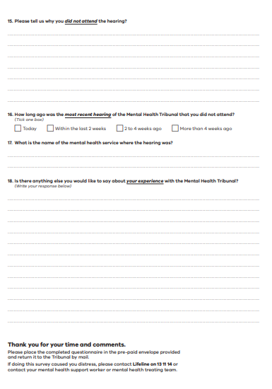

1. Not all patients have family members, carers or nominated persons.
2. The 2022 Annual Report was not available at the time of reporting.
3. For 2022, the attendance rate was calculated from the [Mental Health Tribunal Annual Report 2020-2021](https://www.mht.vic.gov.au/sites/default/files/documents/202111/2020-2021%20MHT%20Annual%20Report.pdf)